**HOSTEL AUTOMATION SYSTEM – DATA FLOW DIAGRAM**

**ZEROTH LEVEL DFD FOR HOSTEL AUTOMATION SYSTEM**

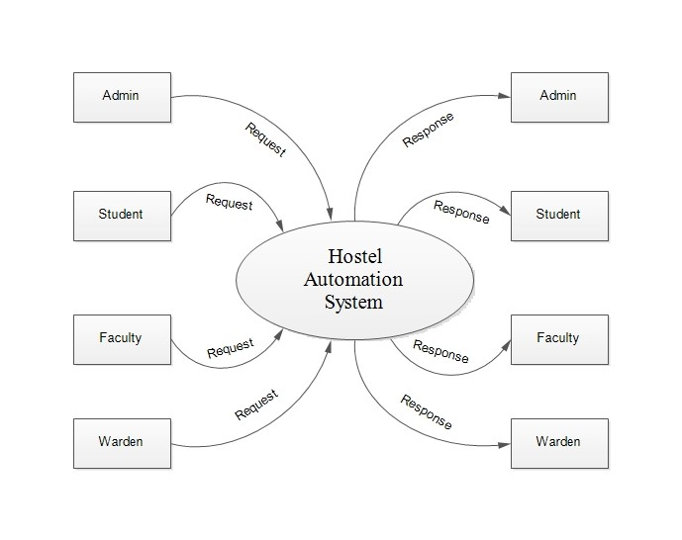

**FIRST LEVEL DFD FOR HOSTEL AUTOMATION SYSTEM – ADMIN**

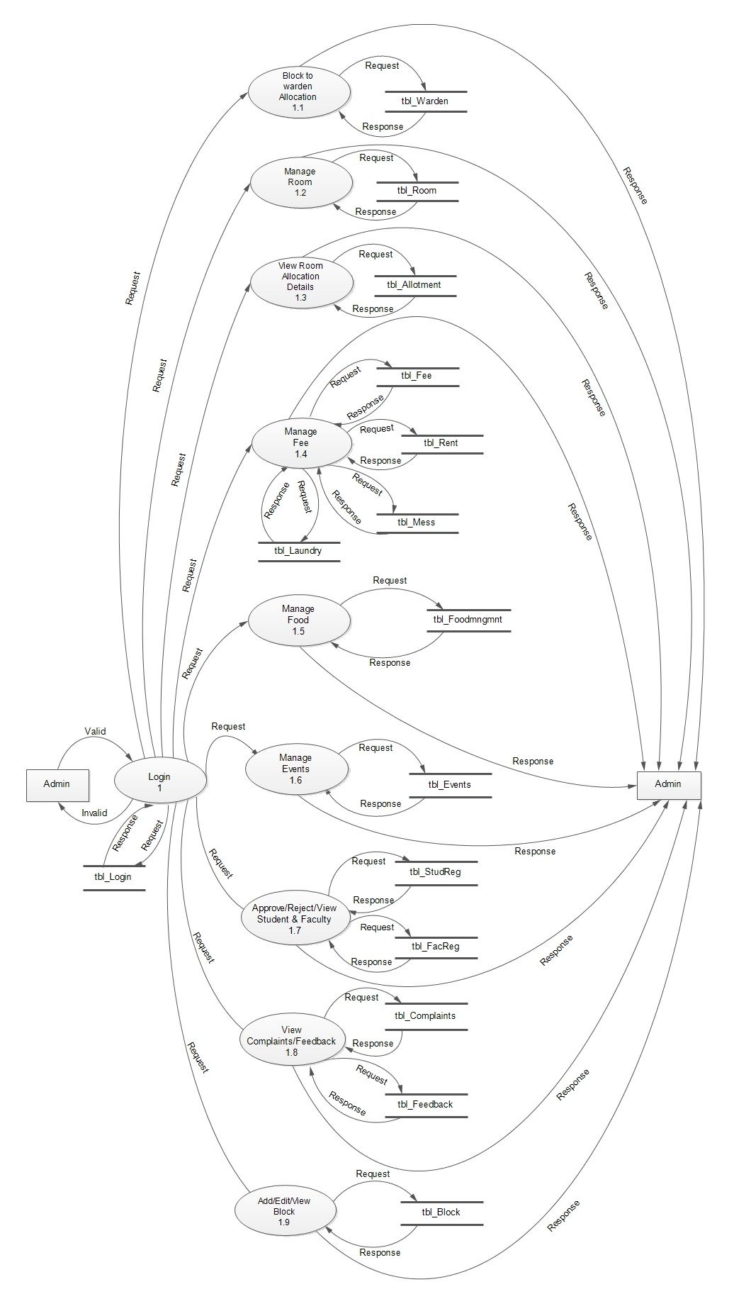

**FIRST LEVEL DFD FOR HOSTEL AUTOMATION SYSTEM – WARDEN**

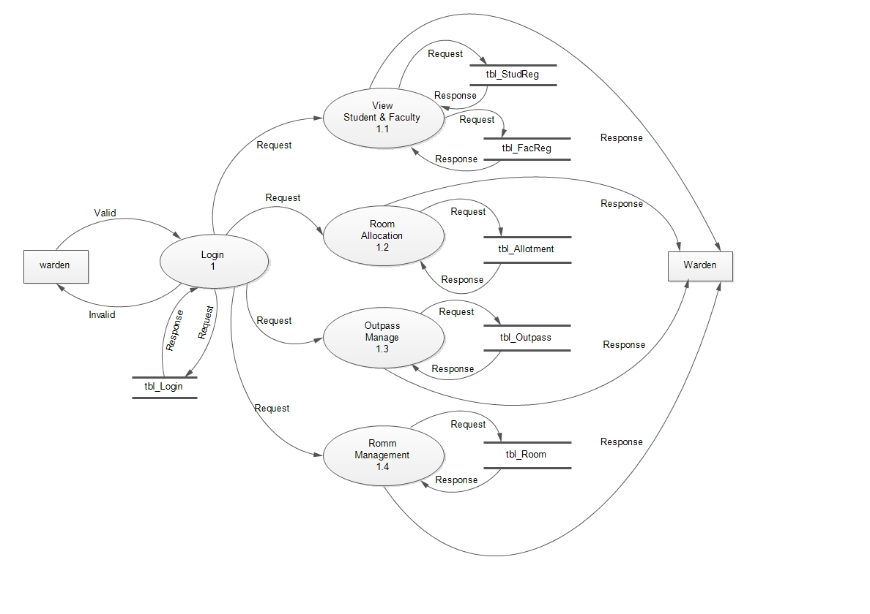

**FIRST LEVEL DFD FOR HOSTEL AUTOMATION SYSTEM – STUDENT**

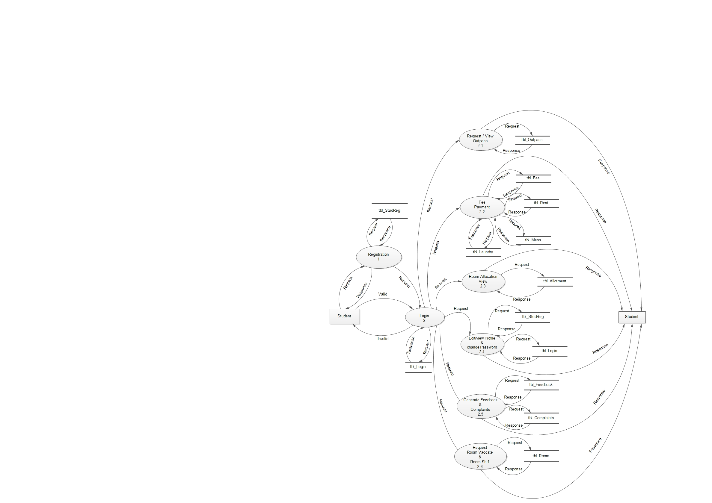

**FIRST LEVEL DFD FOR HOSTEL AUTOMTION SYSTEM – FACULTY**

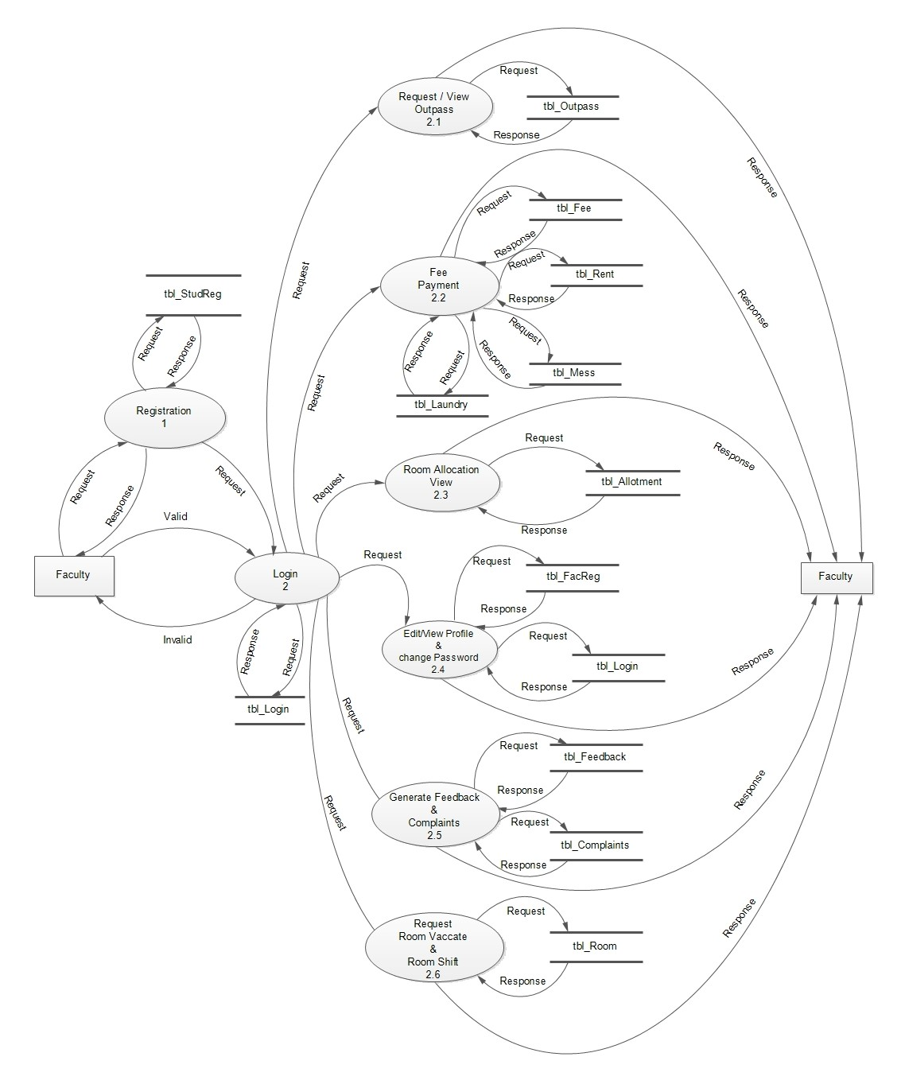

**SECOND LEVEL DFD FOR HOSTEL AUTOMATION SYSTEM – WARDEN**

